
School: ............................................................................................................. Campus: ....................................................... Academic Year: ...................... Subject Name: ........................................................... Subject Code: ..........................
Semester: ............... Program: ........................................ Branch: ......................... Specialization: .......................... Date: .....................................
(Learning by Doing and Discovery)
* Coding Phase: Pseudo Code / Flow Chart / Algorithm
Gather the Transaction Data:
- Launch your Solidity development environment (IDE).
- Create a new Solidity file.
- Open your browser that has MetaMask installed.
- In MetaMask, choose a blockchain network — for example, Ethereum Sepolia.
- Copy your MetaMask wallet address (your public key).
- In a separate browser tab, search for an Ethereum Sepolia faucet.
- Make sure the network is set to Ethereum Sepolia.
- Paste your wallet’s public address into the provided field.
- Click the button to receive Sepolia test tokens.
B. Break Down the Transaction:
- Write your smart contract in Remix IDE.
- Compile the contract.
- Go to Deploy & Run Transactions → Set Environment to Injected Provider – MetaMask.
- Deploy the contract to the selected network

Coding Phase: Pseudo Code / Flow Chart / Algorithm
In MetaMask – What “Dissecting” a Transaction Means
1. Before sending – Review carefully:
- Check the sender and recipient addresses.
- Confirm the network (e.g., Ethereum Mainnet, Sepolia testnet).
- Review the gas settings (max fee per gas, gas limit).
- Identify the transaction type — whether it’s a basic ETH transfer, a smart contract call, or a token transfer.
- Look at the data field to see if it’s interacting with a smart contract.
2. After sending – Inspect in a block explorer (e.g., Etherscan):
- View the transaction hash (unique identifier).
- Check the block number where it was recorded.
- See the status (successful or failed).
- Note the gas actually used.
- Examine the events or logs generated by the smart contract.
- Verify the value transferred and the function executed.

In Remix IDE – When Running a Transaction
When you execute a function (such as calling a smart contract method) in Remix, it displays:
- Transaction cost in gas and ETH.
- Execution cost (gas used, excluding deployment overhead).
- Decoded input (function name and its parameters).
- Decoded output (returned values).
- Logs from any events triggered by the contract.
- Debugging tab — lets you go step-by-step through opcodes and track changes to contract storage.

* Softwares used
- Remix IDE
- MetaMask Wallet

- Testing Phase: Compilation of Code (error detection)
- 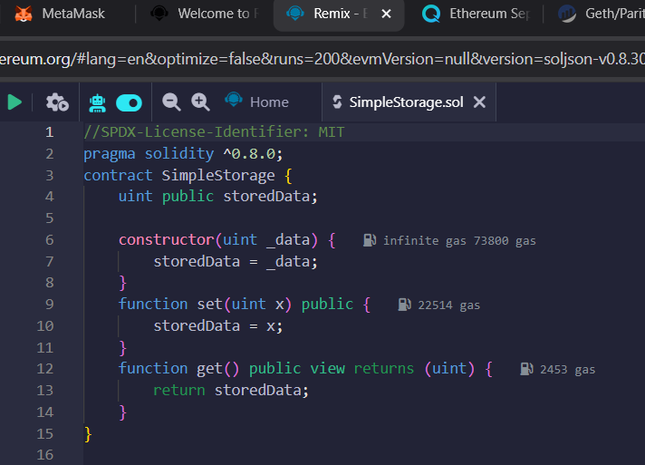

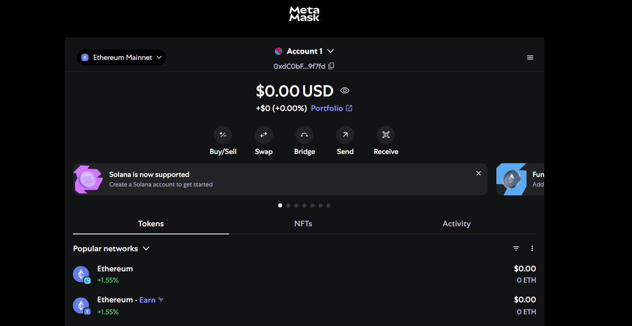
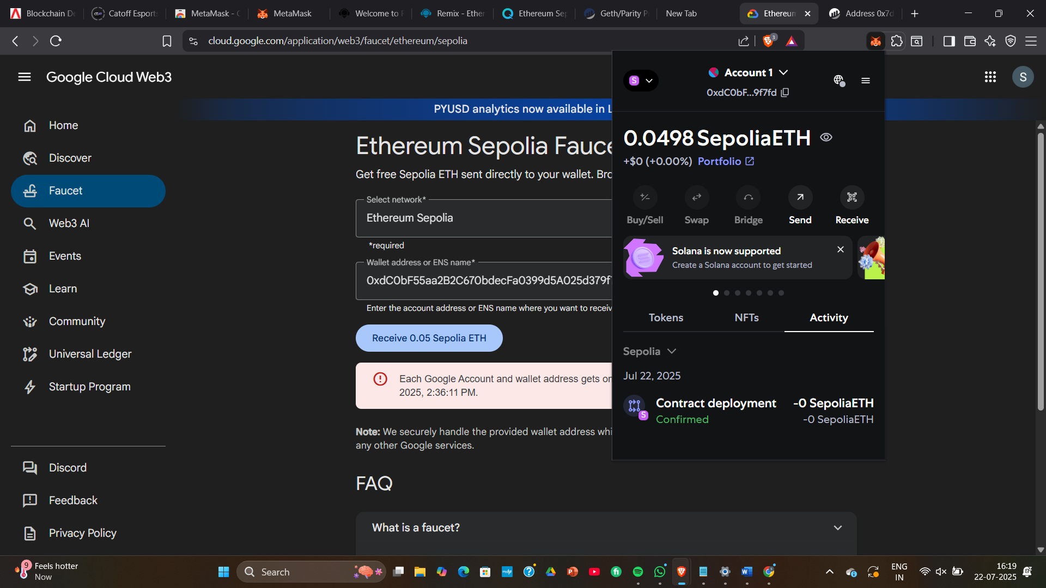

- Testing Phase: Compilation of Code (error detection)
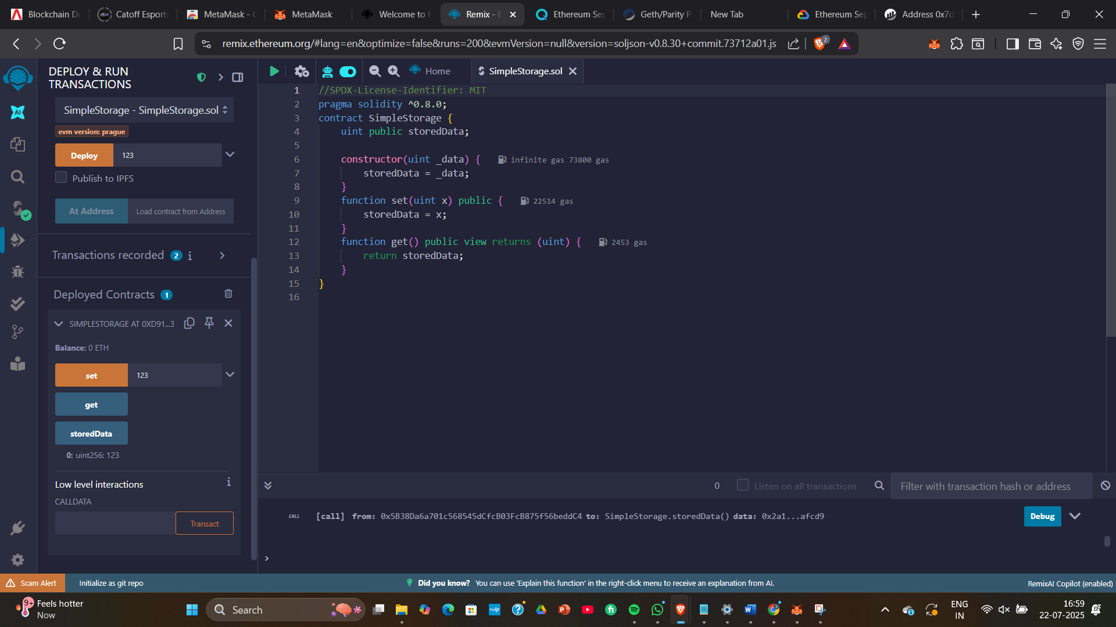

Implementation Phase: Final Output (no error)

- Implementation Phase: Final Output (no error)
Applied and Action Learning

* Observations

ASSESMENT

Rubrics
Concept | 10
Planning and Execution/  Practical Simulation/ Programming | 10
Result and Interpretation | 10
Record of Applied and Action Learning | 10
Viva | 10
Total | 50


Signature of the Student:
Signature of the Faculty:

